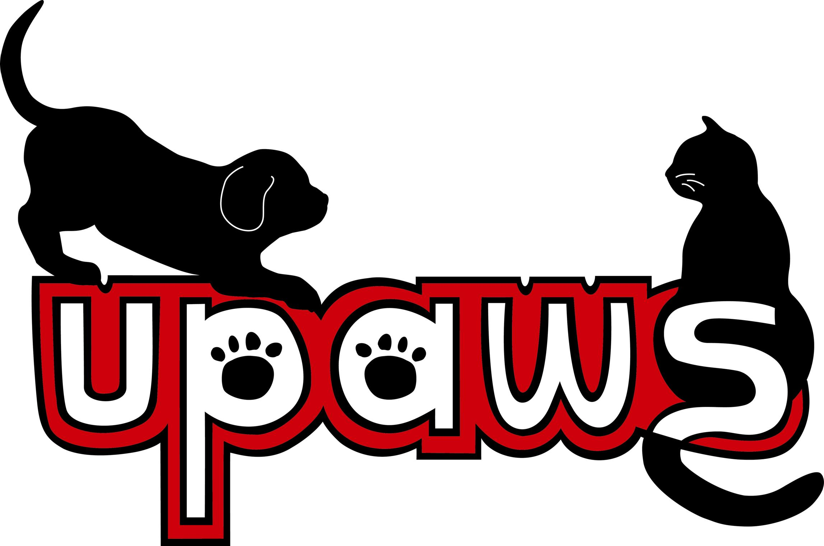Imagine the PAWSibilities
Campaign for an Animal Community Center
___ I/We pledge a total gift of $ ______________________________
___ I/We are interested in naming ____________________________

Name(s) ______________________________________ Email__________________________________

Address _______________________________City ___________________ State ______ Zip __________
Home Phone ______________________ Cell Phone ____________________

Payment Method:

____Total payment enclosed

____ Time payment ____ Monthly ____Quarterly ____ Semi Annually ____ Annually

Starting on: ________________ Each payment: $______________
____ Please send me a reminder when gift is due ___ Email ___ Mail

____Automatic Withdrawal Name on Account ____________________________________

___ Checking (Enclose voided Check) ___Savings (enclose deposit slip)

____Charge my credit card ___ Mastercard ___ American Express ___ Discover ___ VISA ___Other

Name on card ____________________Number ______-______-______ Exp. Date ______ Security Code_____

____Gift of Stock: Please transfer to UPAWS Wells Fargo account using Account # 1701 and
DTC # 0141 (Please notify UPAWS of stock gifts to ensure appropriate gift acknowledgement)
Your broker name and contact number ___________________________________________

___ In-Kind Gift: Please contact me about a gift in kind.

Gift made in honor □ or memory □ of ___________________________________________________

May we publish your name in recognition materials? Yes __ No __
Please publish as _________________________________________________________

Signature ________________________________________________Date ______________

Phone: 906-475-6661 Website: upaws.org Email: campaign@upaws.org Box 968, Marquette, 49855
Imagine the PAWSibilities
Campaign for an Animal Community Center

NAMING OPPORTUNITIES
Given the size and scope of the Animal Community Center Campaign, UPAWS has established a number of giving opportunities.
Many options still available or consider a custom naming option.

CENTER
Animal Community Center $1,000,0000
Welcome Lobby $ 250,000
Community Education Room $ 250,000
Visitors Outdoor Porch $ 75,000
After Hours Vestibule $ 25,000
Landscaping & Benches $ 5,000

FELINE FRIENDS
Condo Village $ 75,000
Colony with Sun Porch $ 40,000
Featured Cat Room $ 40,000
Cat Playroom $ 25,000
Health Hold Room $ 15,000
Health Isolation $ 15,000
Cat Condo $ 10,000

CANINE COMPANION
Community Dog Park $ 125,000
Village Indoor Run $ 100,000
Featured Dog Room $ 40,000
Real Life Room $ 25,000
Get Acquainted Room $ 25,000
CANINE COMPANION (continued)
Health Hold Room $ 15,000
Health Isolation $ 15,000
Private Kennel $ 10,000
Outdoor Play Yard $ 10,000

LARGE ANIMALS/SMALL CRITTERS
Large Animal Barn $ 75,000
Large Animal Paddock $ 20,000
Large Animal Lean-To $ 15,000
Large Animal Barn Stall $ 10,000
Small Critter Room $ 20,000

ANIMAL CARE SUPPORT
Veterinarian Clinic $ 75,000
Adoption Counseling Room $ 20,000
Shelter Staff Offices $ 10,000
Shelter Staff Main Office $ 25,000
Grooming Parlor $ 10,000
Food Preparation Room $ 5,000
Laundry $ 5,000

Upper Peninsula Animal Welfare Shelter, Inc.

